ASSIGNMENT-4.1
NAME: R.Karthik
H.T.NO:2303A52202
BATCH:35

Customer Email Classification
A company receives a large number of customer emails every day
and wants to automatically classify them into the following
categories:
• Billing
• Technical Support
• Feedback
• Others
Instead of training a new machine learning model, the company
decides to use prompt engineering techniques with an existing large
language model.
Tasks
1. Prepare five short sample emails, each belonging to one of
the above categories.
2. Write a zero-shot prompt to classify a given email into one of
the categories without providing any examples.
3. Write a one-shot prompt by including one labeled email
example and ask the model to classify a new email.
4. Write a few-shot prompt by including two or three labeled
email examples and ask the model to classify a new email.
5. Compare the outputs obtained using zero-shot, one-shot, and
few-shot prompting techniques and briefly comment on their
effectiveness.
CODE:
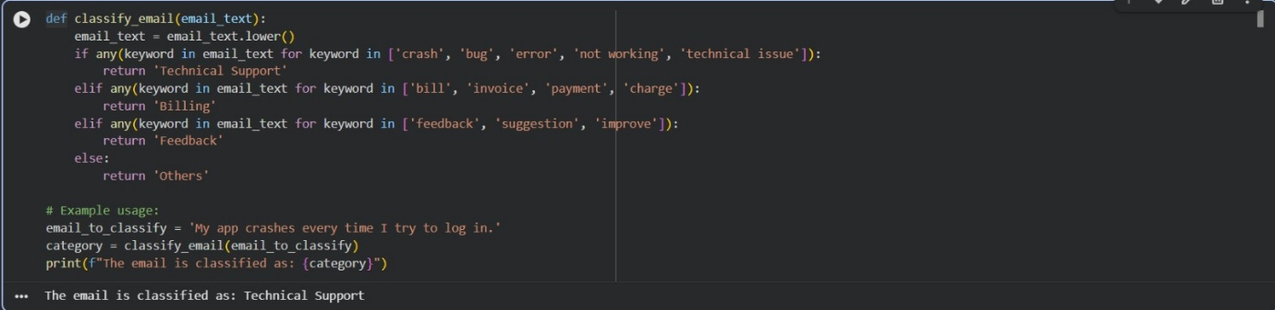
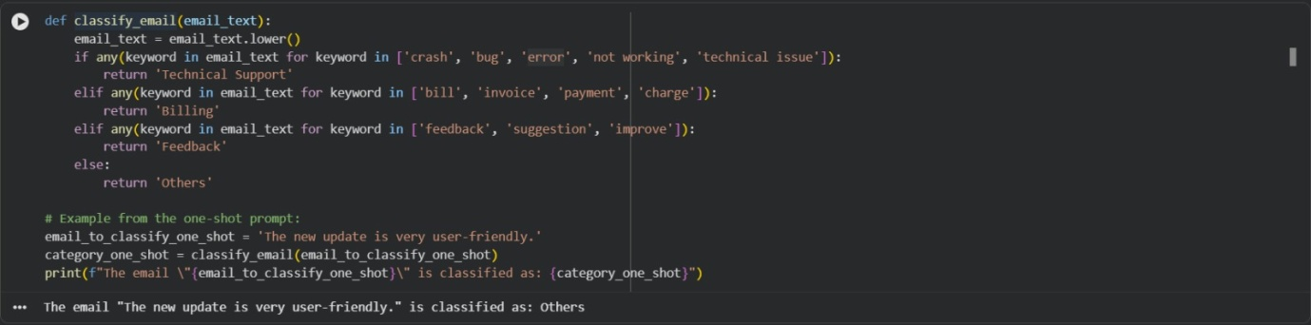
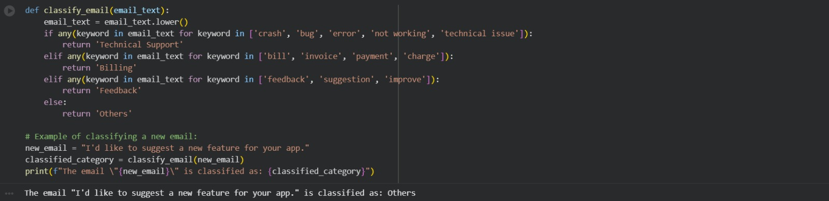
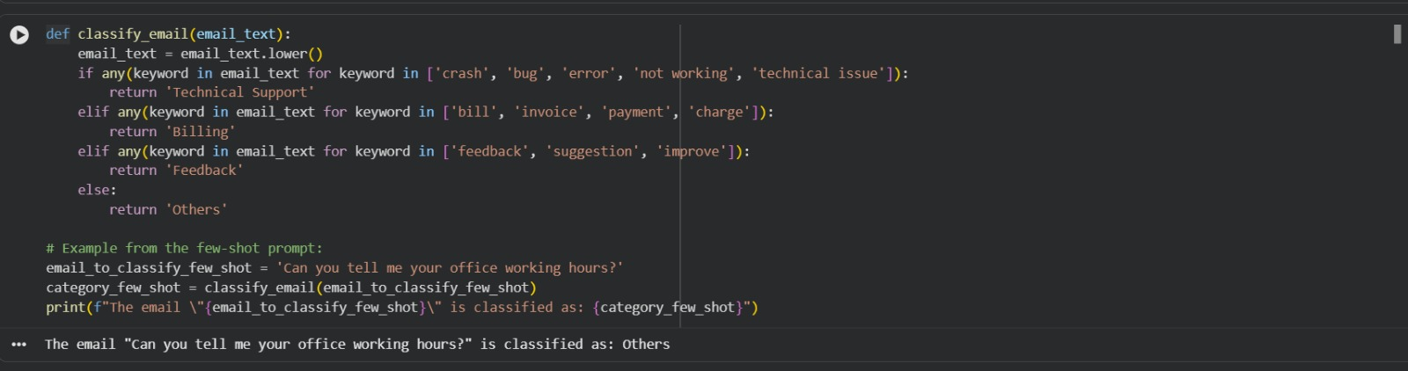
Intent Classification for Chatbot Queries
A company wants to deploy a chatbot to handle customer queries.
Each query must be classified into one of the following intents:
Account Issue, Order Status, Product Inquiry, or General Question
using prompt engineering techniques.
Tasks to be Completed
1. Prepare Sample Data
Create 6 short chatbot user queries, each mapped to one of
the four intents.
2. Zero-shot Prompting
Design a prompt that asks the LLM to classify a user query
into the given intent categories without examples.
3. One-shot Prompting
Provide one labeled query in the prompt before classifying a
new query.
4. Few-shot Prompting
Include 3–5 labeled intent examples to guide the LLM before
classifying a new query.
5. Evaluation
Apply all three techniques to the same set of test queries and
document differences in performance.
CODE:
